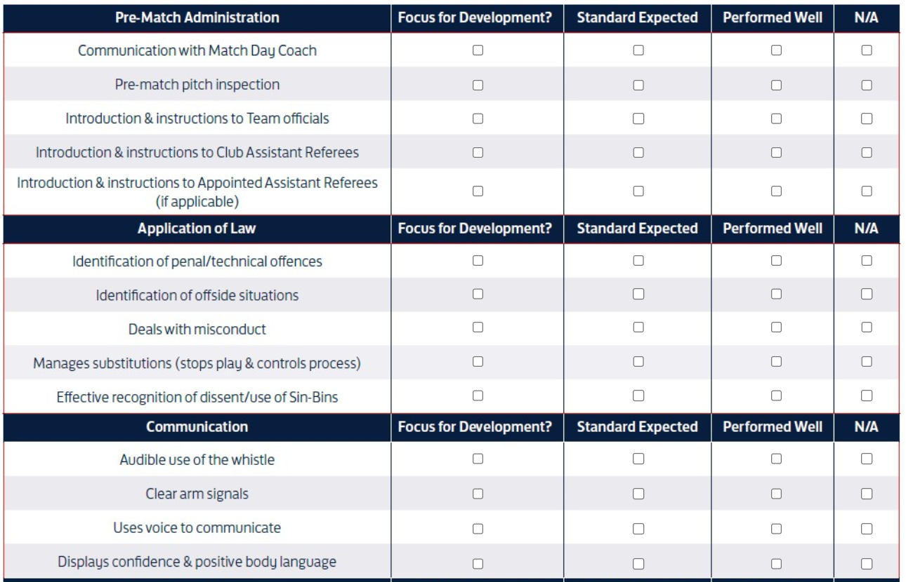
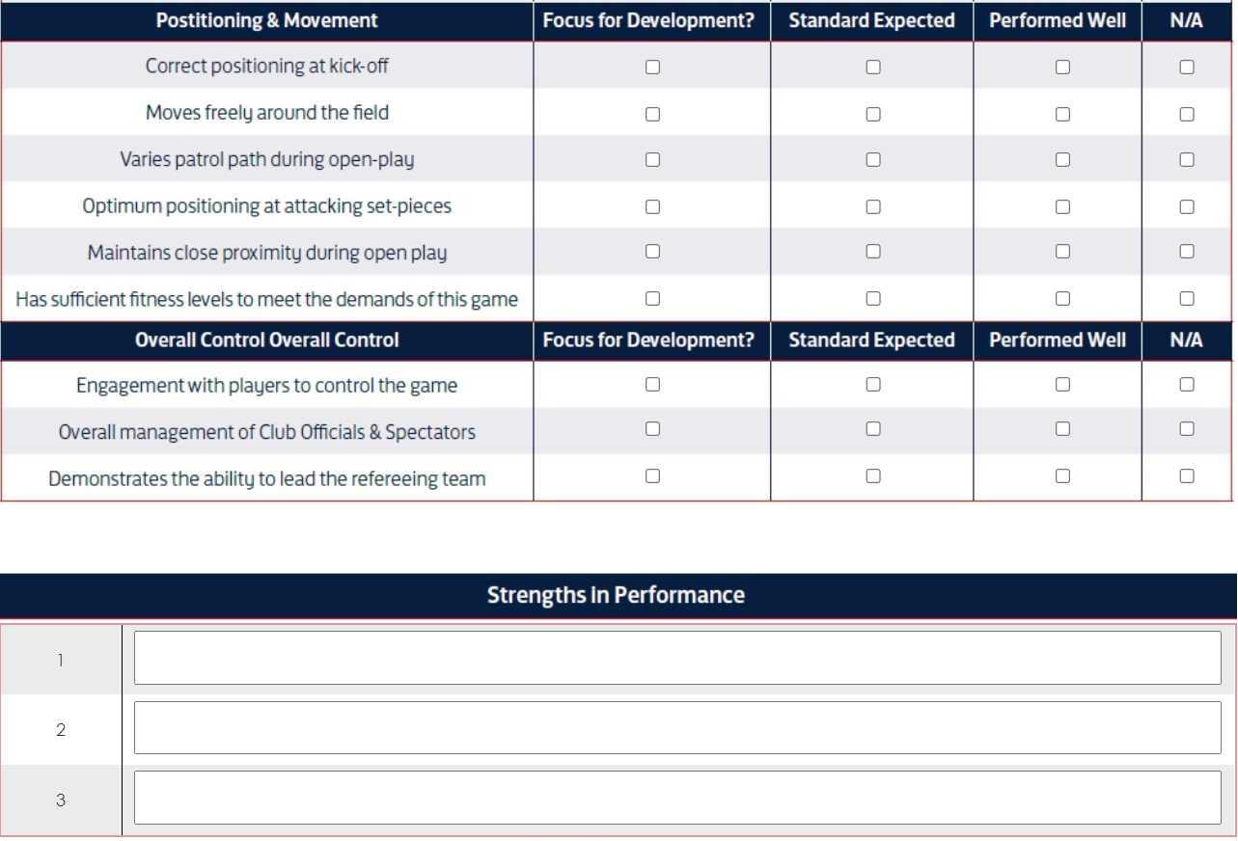
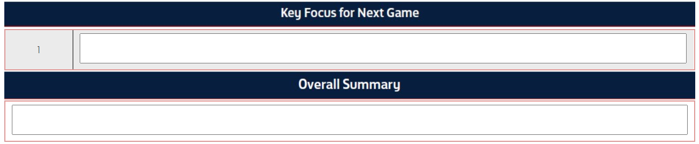

Post Match
Well done – How do you find that?
Please confirm your cautions
Code | Description
C1 | Unsporting Behaviour – further defined as:  AA Adopting an aggressive attitude  DI Simulation  DP Dangerous Play  FT Foul Tackle  GC Goal Celebration  HB Handball  RP Reckless Play  SP Pushing or Pulling an opponent  TR Tripping  UB Unspecified Behaviour
Cn | 2 - Dissent or 2 Dissent (sin bin); 3 - Persistent; 4 - Delays; 5 - Distance; 6 - Enter/re-enters; 7 - Leaves
S2 | Violent Conduct: Head to Head; Elbowing; Kicking; Stamping; Striking; Biting; Other
Sn | 1 - Serious Foul Play +; 2 - Violent Conduct; 3 - Spitting; 4 - DOGSO hand; 5 -DOGSO (FK); 6- Language; 7 - Second Yellow

Discuss & Check KMIs.
Next match ?
Other things to go with – Indirect FK, Vary position, AR management
3 goods I’m going for
Any questions
Written report will be with you after FA have seen it and forwarded
Thank you

